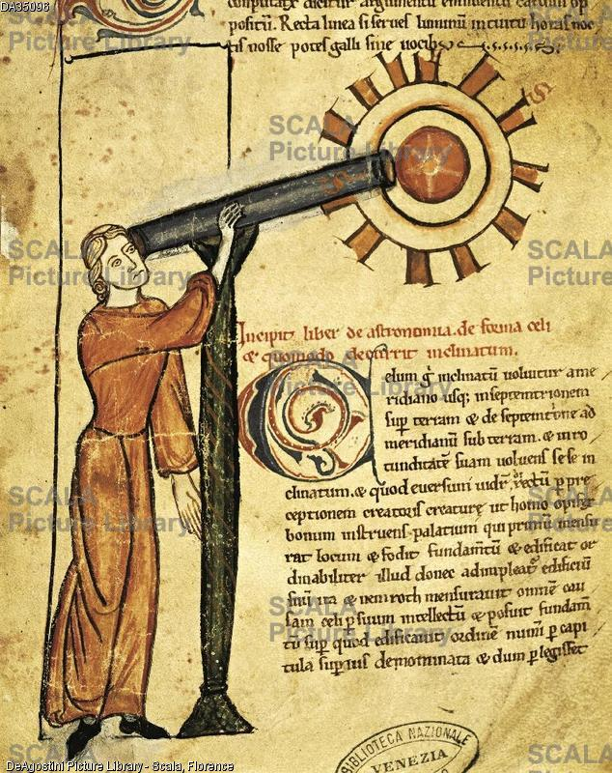
Title: Astronomy, miniature from a treatise on astrology, Latin manuscript, Italy 14th Century. Location: Marciana Library, City: Venice, Country: Italy
Notice telescope ("14th Century"?) at least two hundred years before Galileo Galilei (circa 1600). Notice also the star in the middle of whatever the object (the Sun ?) is, toward which the telescope is pointed.

